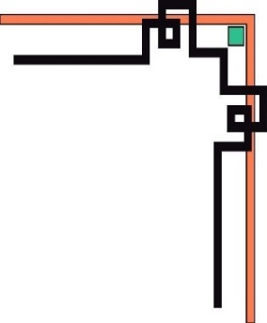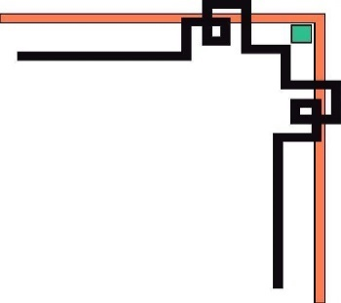

**MINISTRY OF EDUCATION AND TRAINING**

**HO CHI MINH CITY**

**UNIVERSITY OF TECHNOLOGY AND EDUCATION**

**FACUTLY OF INFORMATION TECHNOLOGY**

**🕯✡🕮🕮✡🕯**



**WEB PROGRAMMING**

**PROJECT REPORT**

***TOPIC: BOOKING TICKET ONLINE***

***SUPERVISOR: Professor***. ***Mai Anh Thơ***

|  |  |  |
| --- | --- | --- |
| No | Full name | Student ID |
| 1 | Đỗ Quang Triệu | 21110805 |
| 2 | Hoàng Long Vũ | 21110113 |
| 3 | Hồ Hữu Nhân | 21110787 |

***Ho Chi Minh City , December 2023***

**IMAGE INDEX**

**Figure 1 Class Diagram 3**

**Figure 2 Database Diagram 3**

**Figure 3. Seat class entity 5**

**Figure 4 Showtime entity 6**

**Figure 5 Ticket entity 7**

**Figure 6 Room entity 8**

**Figure 7 Movie entity 9**

**Figure 8 Invoice entity 10**

**Figure 9 Customer entity 11**

**Figure 10 File Tree Structure 12**

**Figure 11 Admin movie servlet 12**

**Figure 12 Admin room servlet 14**

**Figure 13 Admin showtime servlet 16**

**Figure 14 Admin statistic servlet 17**

**Figure 15 User login servlet 18**

**Figure 16 User servlet 19**

**Figure 17 User showing servlet 20**

**Figure 18 User ticket servlet 21**

**Figure 19 User seat servlet 22**

**Figure 20 Homepage 24**

**Figure 21 Add balance detail 24**

**Figure 22 Change password detail 25**

**Figure 23 Login page 26**

**Figure 24 Sign up detail 26**

**Figure 25 Forgot password detail 27**

**Figure 26 Showing movie page 28**

**Figure 27 Browse showing movies 28**

**Figure 28 Tickets page 29**

**Figure 29 Ticket detail 29**

**Figure 30 Refund detail 29**

**Figure 31 Film page 30**

**Figure 32 Booking page 31**

**Figure 33 Check out detail 31**

**Figure 34 Admin page and movies detail 32**

**Figure 35 Room details 32**

**Figure 36 Showtime detail 32**

**Figure 37 Statistics detail 33**

**TABLE INDEX**

Table 1 Admin movie servlet methods 13

Table 2 Admin room servlet methods 14

Table 3 Admin showtime servlet methods 16

Table 4 Admin statistic servlet methods 17

Table 5 User login servlet methods 18

Table 6 User servlet methods 19

Table 7 User ticket servlet methods 21

Table 8 User seat servlet methods 22

Table 9 User film servlet 23

Table 10 User film servlet methods 23

CONTENTS

**CHAPTER 1: INTRODUCTION 1**

**1.1. Introduction. 1**

**1.2. Reasons for making project. 1**

**1.3. Usage of the Project. 1**

**CHAPTER 2: DEVELOPMENT ENVIRONMENT 2**

**CHAPTER 3: SYSTEM ANALYSIS AND DESIGN 3**

**3.1. Backend. 3**

3.1.1. Class diagram 3

3.1.2. Database Diagram 3

3.1.3. Entity 5

3.1.4. Servlet 12

**3.2. Frontend. 24**

3.2.1. Home page. 24

3.2.2. Login page. 26

3.2.3. Showing movies page. 28

3.2.4. Tickets page. 29

3.2.5. Film page. 30

3.2.6. Booking page 31

3.2.7. Admin page 32

**CHAPTER 4: CONCLUSION 34**

**4.1. Conclusion: 34**

**4.2. References: 35**

# **CHAPTER 1: INTRODUCTION**

## **1.1. Introduction.**

* The aim of this project is to explore the phenomenon of booking film online, and to analyze its advantages and disadvantages for the film industry and the film viewers. The project will also examine the different online platforms that offer film booking services, and compare their features, prices, and catalogues. The project will also investigate the impact of booking film online on the film culture and the film market, and discuss the future trends and challenges of this mode of film consumption.

## **1.2. Reasons for making project.**

* Booking film online is a growing trend in the film industry and the film audience, and it is important to understand its characteristics, motivations, and impacts on both sides.
* Booking film online is a complex phenomenon that involves various factors and dimensions, such as technology, economy, culture, and society, and it requires a systematic and comprehensive analysis to capture its essence and implications.
* Booking film online is a relevant and timely topic that reflects the current and future challenges and opportunities of the film industry and the film audience, and it can provide valuable insights and recommendations for improving and enhancing the film experience and the film market.

## **1.3. Usage of the Project.**

- The Booking Film Online Website can be used for users and admin in the following ways:

+ User:

* Browse a wide range of films from various genre.
* Compare specifications and prices of different film.
* Read reviews and ratings, and description of products before booking.
* Refund the tickets if you want to change the decision.
* Checking the showtime before booking.

+ Admin:

* Admin can add, update, delete film, showtime, room, and seatclass.
* Browse a wide range of films for above purposes.
* Statistics on money and ticket numbers.
* Manage inventory of film through the platform.

# **CHAPTER 2: DEVELOPMENT ENVIRONMENT**

**IDE: Apache-NetBeans-19**

* Apache NetBeans 19 is a powerful and user-friendly integrated development environment (IDE) that supports Java SE, Java EE, and many other languages. It provides fast and smart editing, code completion, refactoring, debugging, testing, and deployment tools. It also supports the latest Java features such as records, pattern matching, and text blocks.

**Server: Apache-tomcat-9.0.80**

* Apache Tomcat 9.0.80 is an open-source web server and servlet container that implements the Jakarta Servlet, Jakarta Server Pages, Jakarta Expression Language, and Jakarta WebSocket specifications. It offers high performance, scalability, and integration with native server technologies. It also supports HTTP/2, TLS virtual hosting, and multiple certificate support. Apache Tomcat 9.0.80 is compatible with Java SE 8 and later versions.

**Java version: jdk-20.0.2**

* JDK 20.0.2 is the latest update release of the Java SE platform. It contains security fixes, bug fixes, and performance improvements. It also includes IANA time zone data 2023c, which reflects the latest changes in daylight saving time and regional settings around the world. JDK 20.0.2 supports the development and execution of Java applications that use the new features and enhancements introduced in Java SE 20, such as sealed classes, foreign-memory access API, and vector API.

 

# **CHAPTER 3: SYSTEM ANALYSIS AND DESIGN**

## **3.1. Backend.**

### 3.1.1. Class diagram

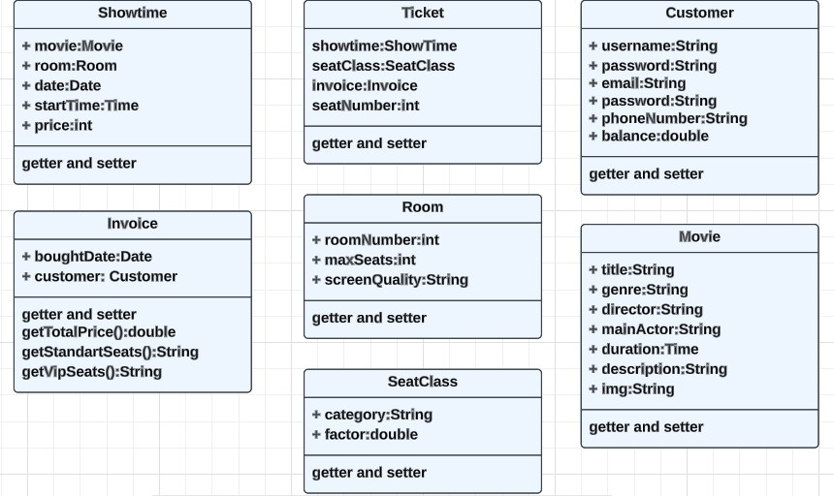

Figure 1 Class Diagram

### 3.1.2. Database Diagram

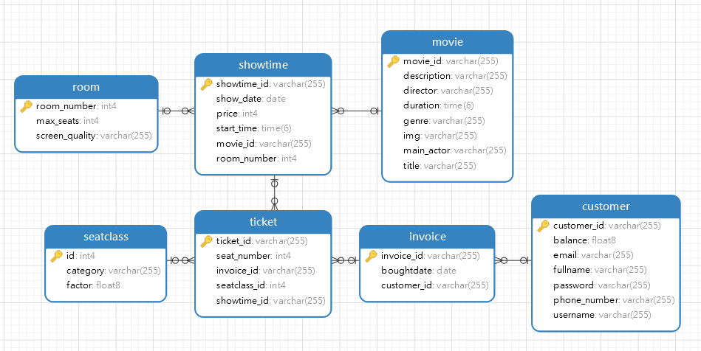

Figure 2 Database Diagram

**Customer table:**

* Contain customer information.
* Fields include customer_id, email, fullname, password, phone_number, balance, and username.
* Relationships:
  1. One-to-Many with invoice: A user can place multiple invoices.

**Invoice table:**

* Contains details about orders of a specific user.
* Fields include invoice_id, boughtdate, customer_id
* Relationships:
* Many-to-One with users: An invoice must belong to a specific customer uniquely.
* One-to-Many with ticket: An invoice can contain one or more than one ticket.

**Ticket table:**

* Contains information about the ticket.
* Fields include ticket_id, seat_number, invoice_id, seatclass_id and showtime_id
* Relationships:

1. Many-to-One with invoice: A ticket must belong to a specific invoice uniquely.
2. Many-to-One with seatclass: A ticket must have only one seatclass.
3. Many-to-One with showtime: A ticket must have only one showtime.

**SeatClass table:**

* Represents the type of seat.
* Fields include id, category, and factor.
* Relationships:
  1. One-to-Many with ticket: A seatclass can belong to many different tickets.

**ShowTime table:**

* Contains details about showtime of a movie.
* Fields include showtime_id, show_date, price, start_time, movie_id, and room_number.
* Relationships:
  1. One-to-Many with ticket: A product can have multiple ticket.
  2. Many-to-One with room: Each showtime is associated with a specific room.
  3. Many-to-One with movie: Each showtime is associated with a specific movie.

**Room table:**

* Information about a room
* Fields include room_number, max_seats, and screen quality.
* Relationships:
  1. One-to-Many with showtime: A room can have multiple showtime in different time.

**Movie table**:

* Contains detail about a movie.
* Fields include movie_id, description, director, duration, genre, img, main_actor and title.
* Relationships:
  1. One-to-Many with showtime: A movie can have multiple showtime.

### 3.1.3. Entity

***SeatClass***

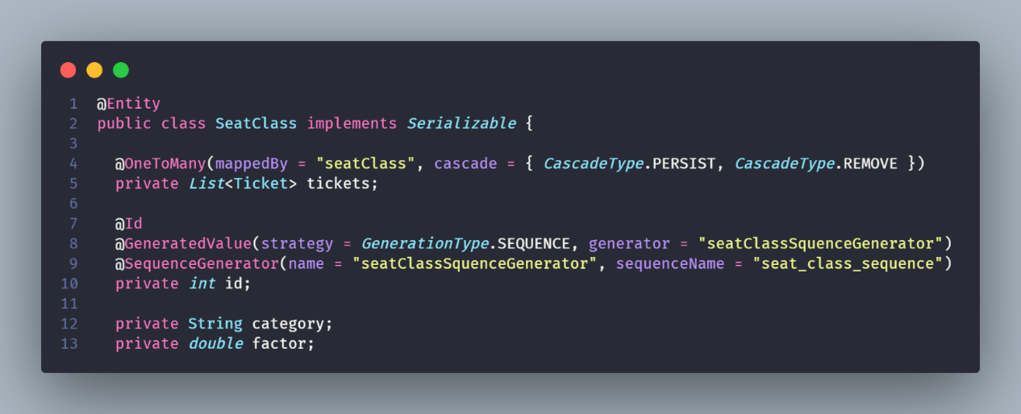

Figure 3. Seat class entity

**Private List<Ticket> tickets:** The tickets field is a list of Ticket objects. It is annotated with @OneToMany, which is a JPA annotation that indicates a one-to-many relationship between SeatClass and Ticket. The mappedBy = "seatClass" attribute indicates that the seatClass field in the Ticket class owns the relationship.

**Private int id**: The id field is the primary key of the SeatClass entity. It is annotated with @Id and @GeneratedValue, which means that the value of id will be automatically generated by the persistence provider.

**Private String category:** The category field is a String that could represent the category of the seat class.

**Private double factor:** represent a factor associated with the seat class in which affect the standart showtime’s price.

***ShowTime***

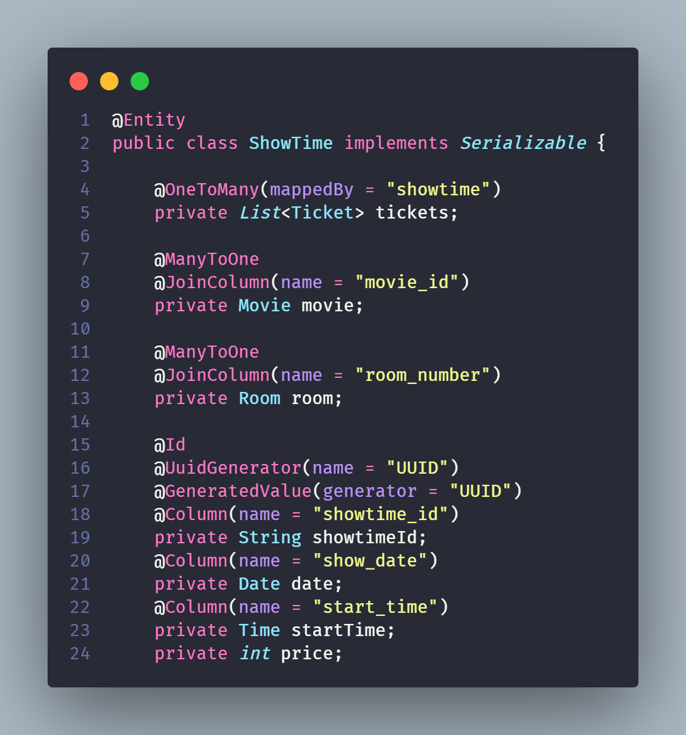

Figure 4 Showtime entity

**Private List<Ticket> tickets:** The tickets field is a list of Ticket objects. It is annotated with @OneToMany, which is a JPA annotation that indicates a one-to-many relationship between ShowTime and Ticket. The mappedBy = "showtime" attribute indicates that the showtime field in the Ticket class owns the relationship.

**Private Movie movie:** each instance of the current class is associated with one instance of Movie.

**Private Room room:** each instance of the current class is associated with one instance of Room.

**Private String showtimeId:** This field is the consider as key of the entity. The @Id annotation indicates that this field is the unique identifier for instances of this class. annotations indicate that the value of this field is automatically generated using a UUID generator.

**Private Date date:** Indicate the showtime’s date.

**Private int price:** Represent for standart price of a showtime.

***Ticket***

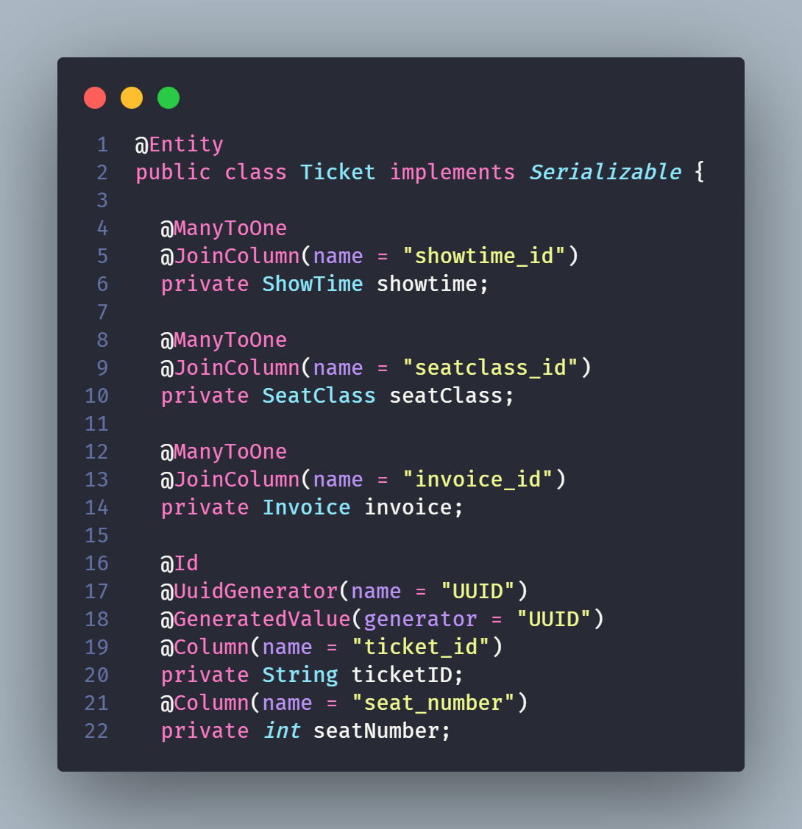

Figure 5 Ticket entity

**Private Showtime showtime:** annotated with @ManyToOne and @JoinColumn, which means that each Ticket is associated with one ShowTime.

**Private SeatClass seatClass**: annotated with @ManyToOne and @JoinColumn, which means that each Ticket is associated with one SeatClass.

**Private Invoice invoice**: annotated with @ManyToOne and @JoinColumn, which means that each Ticket is associated with one Invoice.

**Private String ticketID:** The ticketID field is the primary key of the Ticket entity. Its annotated with @Id and @GeneratedValue, which means that the value of ticketID will be automatically generated by the persistence provider.

**Private int seatNumber:** Represent seat number of a ticket.

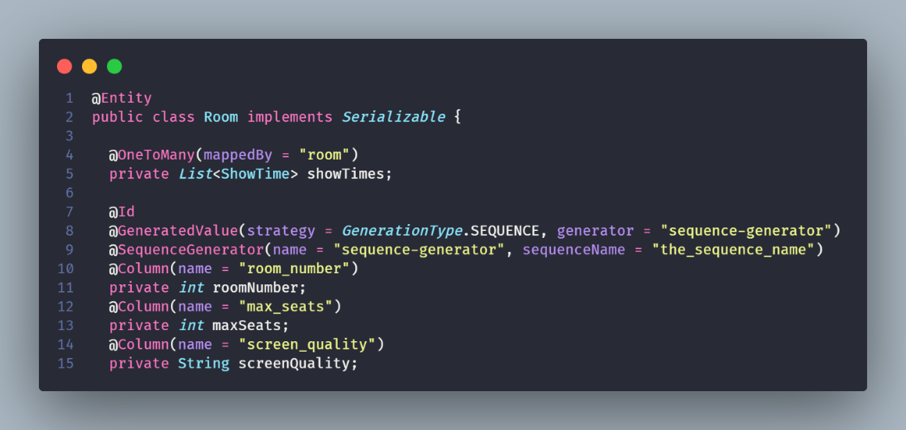***Room***

Figure 6 Room entity

**Private List<Showtime> showtimes:** This field represents a list of ShowTime objects associated with the room.

**Private int roomNumber:** This field represents the room number.

**Private int maxSeats:** This field represents the maximum number of seats in the room.

**Private String screenQuality:** This field represents the quality of the screen in the room.

***Movie***

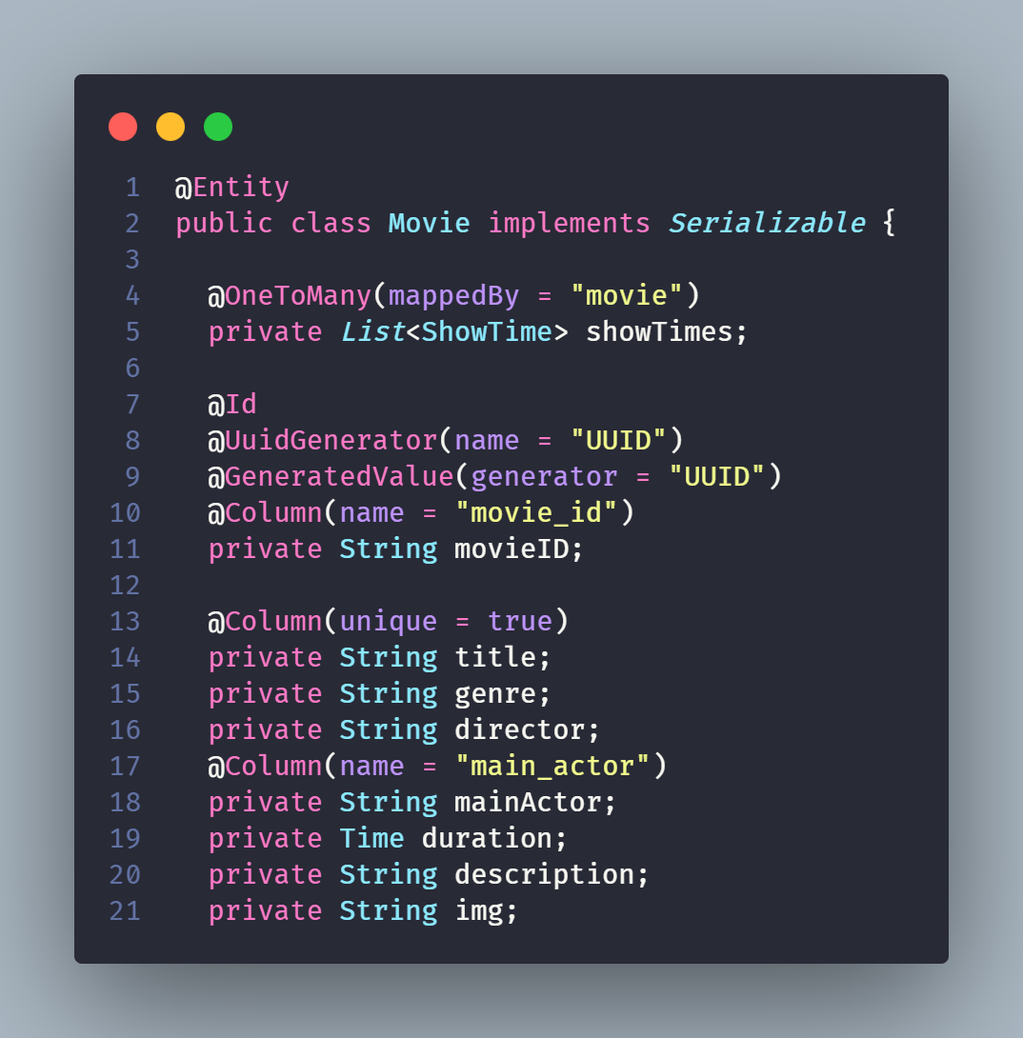

Figure 7 Movie entity

**Private List<ShowTime> showTimes**: This field represents a list of ShowTime objects associated with the movie. It is annotated with @OneToMany to establish a one-to-many relationship between Movie and ShowTime entities.

**Private String** **movieID:** This field is the unique identifier for the movie. It is annotated with @Id to indicate that it is the primary key of the entity.

**Private String** **title:** Represents the title of the movie. The unique attribute is set to true to enforce uniqueness of values in this column.

**Private String** **genre:** Represents the genre of the movie.

**Private String** **director:** Represents the director of the movie.

**Private String** **mainActor:** Represents the main actor/actress of the movie.

**Private String** **duration:** Represents the duration of the movie.

**Private String description:** Represents the description or summary of the movie.

**Private String** **img:** Represents the img file name (such as movie.png).

***Invoice***

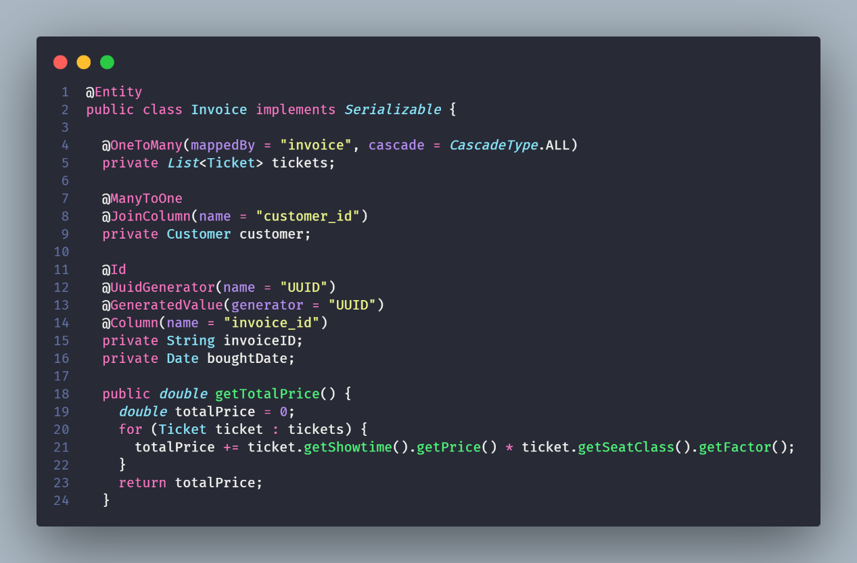

Figure 8 Invoice entity

**Private List<** **Ticket> tickets**: This field represents a list of Ticket objects associated with the invoice. It is annotated with @OneToMany to indicate a one-to-many relationship with the Ticket entity and the mappedBy attribute specifies the inverse side of the relationship.

**Private Customer** **customer:** Represents the customer associated with the invoice. It is annotated with @ManyToOne to indicate a many-to-one relationship with the Customer entity.

**Private String** **invoiceID:** Represents the unique identifier for the invoice. It is annotated with @Id to indicate that it is the primary key of the entity.

**Private Date** **boughtDate:** represents the date when the invoice was created.

**Public double getTotalPrice():** This method calculates and returns the total price of the invoice. It iterates over the tickets list and calculates the total price by multiplying the price of each ticket's showtime with the factor of its seat class.

***Customer***

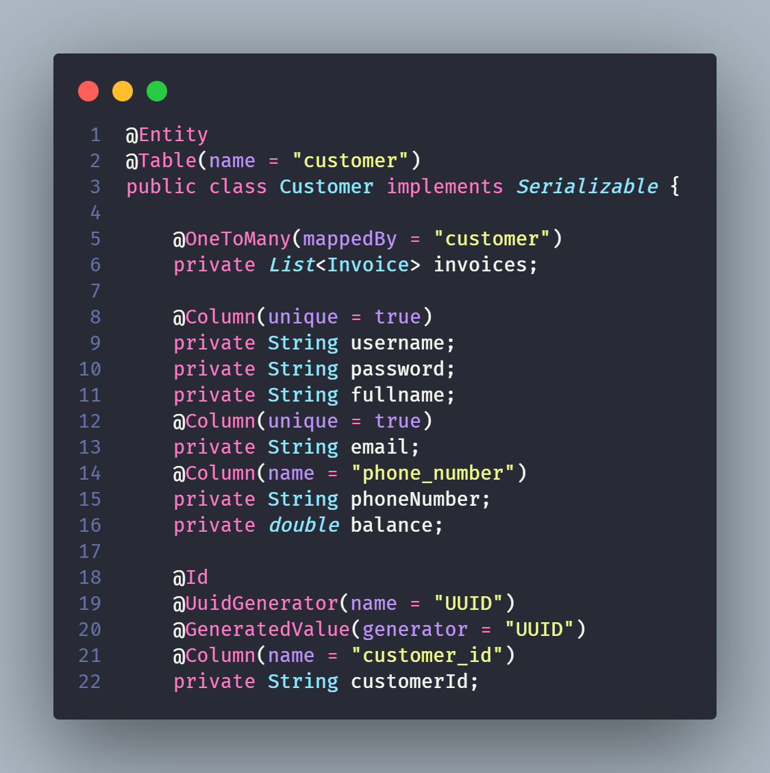

Figure 9 Customer entity

**Private List<** **Invoice> invoices**: This field represents a list of Invoice objects associated with the customer. It is annotated with @OneToMany to establish a one-to-many relationship between the Customer entity and the Invoice entity.

**Private String** **username:** Represents the username of the customer. It is annotated with @Column(unique = true) to ensure that each username is unique in the database.

**Private String** **password:** Represents the password of the customer.

**Private String** **fullname:** Represents the full name of the customer.

**Private String phoneNumber:** Represents the phone number of the customer.

**Private double balance:** Represents the balance amount of the customer.

**Private String customerId:** Represents the phone number of the customer

**Private String phoneNumber:** Represents the unique identifier of the customer. It is annotated with @Id to indicate that it is the primary key of the entity.

### 3.1.4. Servlet

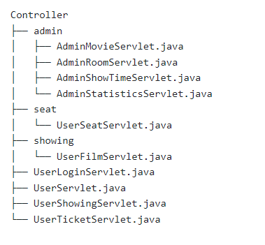

Figure File Tree Structure

1. Admin Movie Servlet

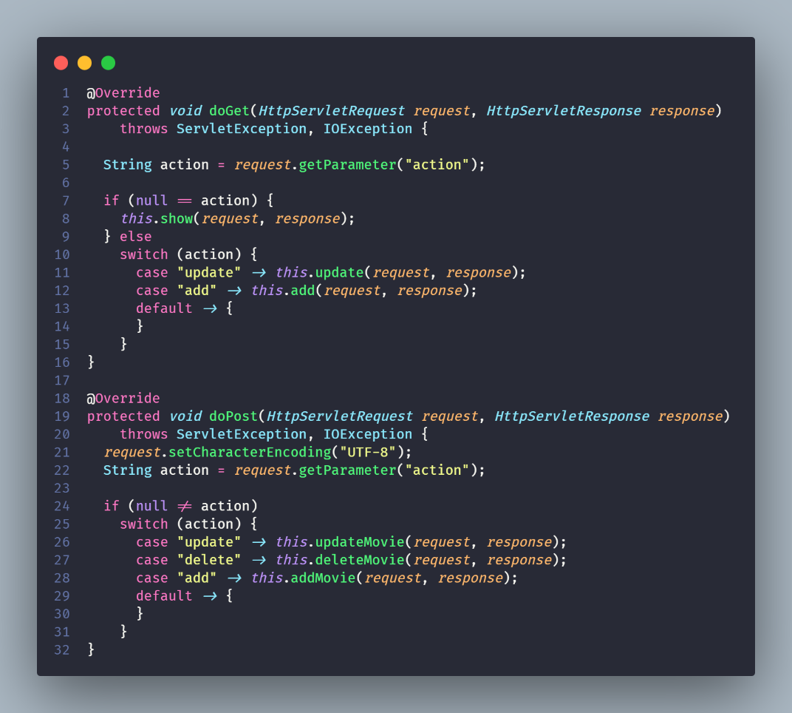

Figure Admin movie servlet

Table 1 Admin movie servlet methods

|  |  |
| --- | --- |
| **Method name** | **Description** |
| update | Take responsibility for navigating to the update movie page. It retrieves the movie ID from the request parameters, selects the corresponding movie from the database, sets the necessary attributes in the request, and forwards the request to the page. |
| show | Take responsibility for navigating to the admin movie page. It retrieves the list of movies from the database, sets the movies as an attribute in the request, and forwards the request to the page. Additionally, if a movie name is provided in the request parameters, it filters the movies by name before forwarding the request. |
| add | Take responsibility for navigating to the add movie page |
| addMovie | Handling the logic of adding a movie. It retrieves the movie details from the request parameters, creates a new Movie object, sets the movie details, and inserts the movie into the database |
| updateMovie | Handling the logic of updating a movie. It retrieves the movie ID and updated movie details from the request parameters |
| deleteMovie | handling the logic of deleting a movie. It retrieves the movie ID from the request parameters, selects the corresponding movie from the database, and deletes the movie from the database |

1. Admin room servlet

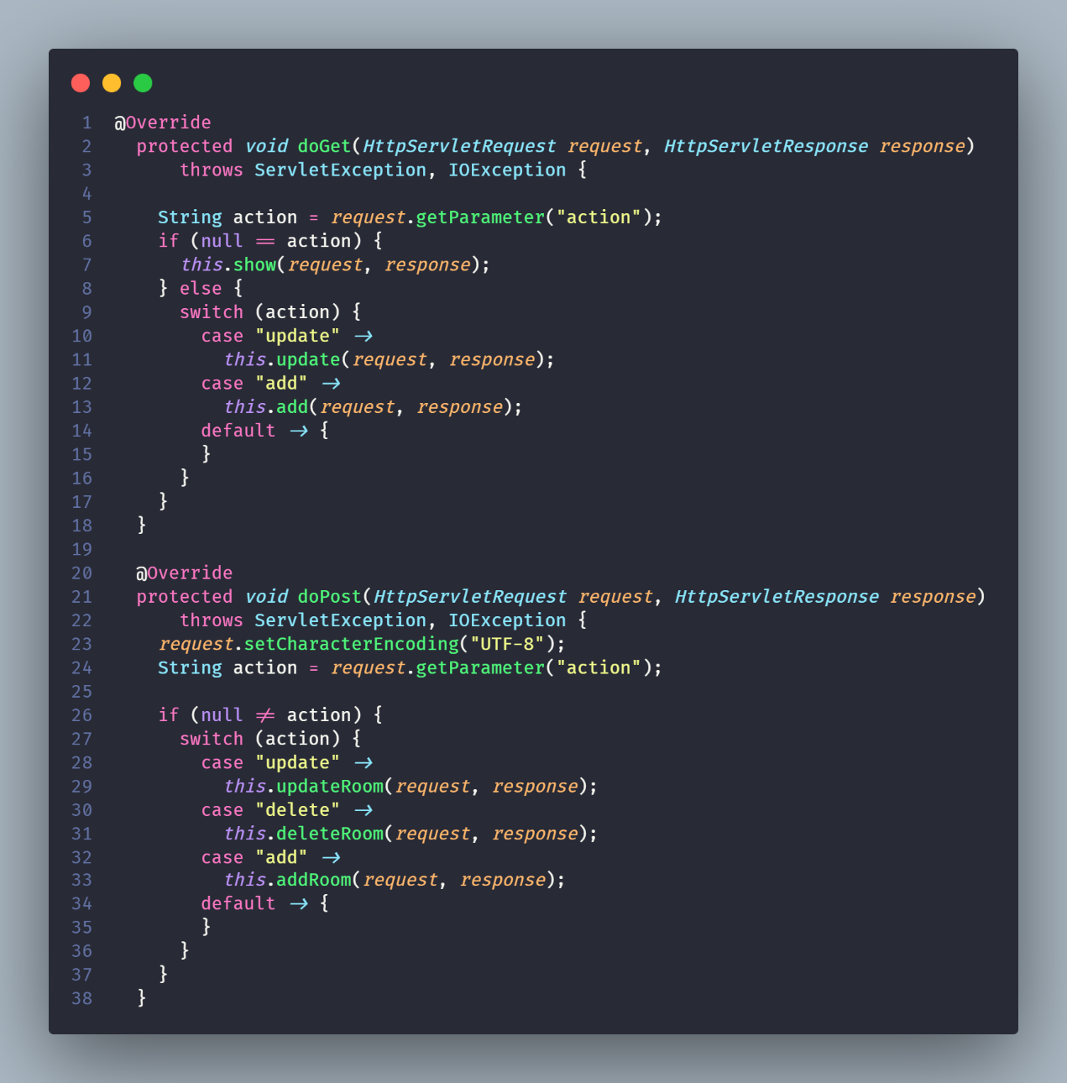

Figure 12 Admin room servlet

Table 2 Admin room servlet methods

|  |  |
| --- | --- |
| **Method name** | **Description** |
| update | Navigating to the update movie page. It retrieves the movie ID from the request parameters, selects the corresponding movie from the database, sets the necessary attributes in the request, and forwards the request to the page |
| show | Navigating to the admin movie page. It retrieves the list of movies from the database, sets the movies as an attribute in the request |
| add | Navigating to the add movie page |
| addMovie | Handling the logic of adding a movie. It retrieves the movie details from the request parameters, creates a new Movie object, sets the movie details, and inserts the movie into the database |
| updateMovie | Handling the logic of updating a movie. It retrieves the movie ID and updated movie details from the request parameters, selects the existing movie from the database using the movie ID, updates the movie details, and updates the movie in the database |
| deleteMovie | Handling the logic of deleting a movie. It retrieves the movie ID from the request parameters, selects the corresponding movie from the database, and deletes the movie from the database |

1. Admin Show Time Servlet

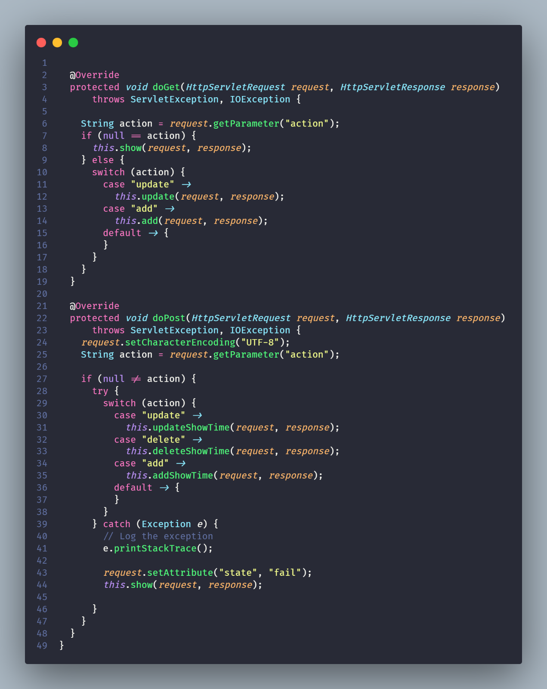

Figure 13 Admin showtime servlet

Table 3 Admin showtime servlet methods

|  |  |
| --- | --- |
| **Method name** | **Description** |
| show | Navigating to the showtime page. It retrieves the showtimes from the database and sets them as attributes in the request object |
| add | Navigating to the add showtime page |
| addShowTime | Handles the addition of a new showtime. It retrieves the necessary values from the request parameters, creates a new ShowTime object, and inserts it into the database. |
| deleteShowTime | Handles the deletion of a showtime. It retrieves the showtime ID from the request parameters, deletes the corresponding showtime from the database, and redirects to the showtime page. |

1. Admin Statistics Servlet

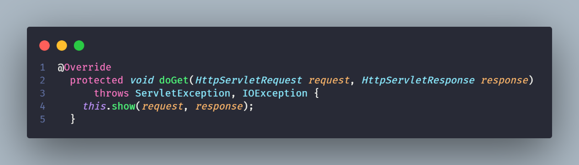

Figure 14 Admin statistic servlet

Table 4 Admin statistic servlet methods

|  |  |
| --- | --- |
| **Method name** | **Description** |
| show | Take responsibility for calculating and setting various statistics related to ticket sales, showtimes, and movies. It retrieves the total revenue from all tickets, the total number of tickets, the total number of showtimes, and the total number of movies from their respective databases. These statistics are then set as attributes in the request object and forwarded to the "statistics.jsp" page for display. |

1. User Login Servlet

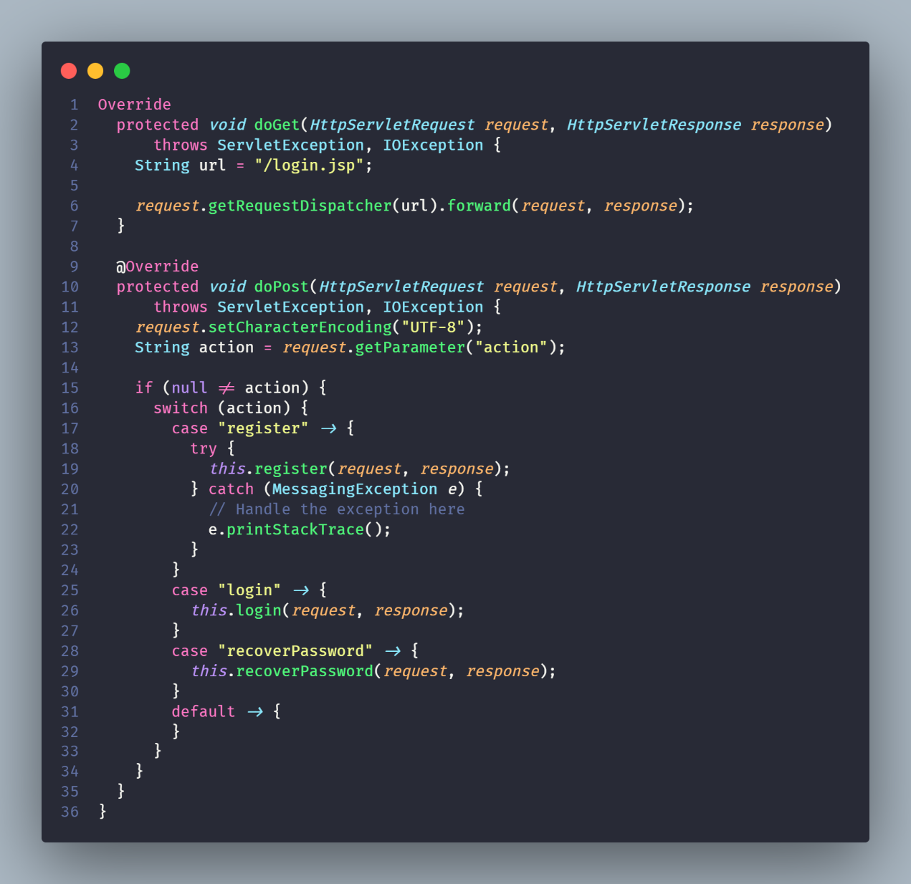

Figure 15 User login servlet

Table 5 User login servlet methods

|  |  |
| --- | --- |
| **Method name** | **Description** |
| Registration | The register method handles user registration. It gets user details from the request, creates a new Customer object, checks if the email or username already exists, and if not, inserts the new customer into the database and sends a confirmation email |
| Login | The login method handles user login. It gets the username and password from the request, checks if they match an existing customer, and if so, stores the customer in the session and optionally creates a cookie for the customer. |
| Password Recovery | The recoverPassword method handles password recovery. It gets the email from the request, checks if it matches an existing customer, and if so, generates a new password, updates the customer in the database, and sends an email with the new password |

1. **User Servlet:**

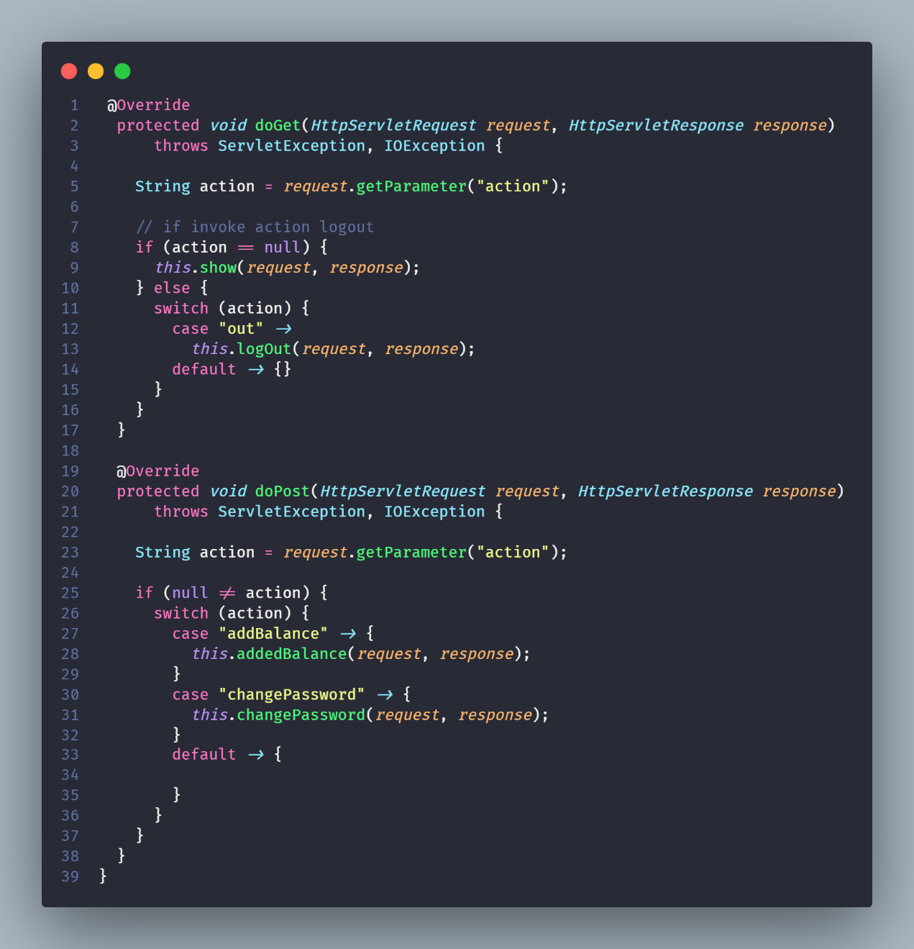

Figure 16 User servlet

Table 6 User servlet methods

|  |  |
| --- | --- |
| **Method name** | **Description** |
| show | This method is invoked when the servlet is accessed without any specific action. It checks for a customer ID in the cookies, retrieves the corresponding customer from the database, and sets it in the session. It also retrieves the top 8 movies from the database and forwards the request to index.jsp for rendering. |
| logOut | This method is invoked when the action is "out". It deletes the customer ID cookie and invalidates the session, then redirects to the context path. |
| addedBalance | This method is invoked when the action is "addBalance". It retrieves the customer from the session and the balance to be added from the request, updates the customer's balance in the database, and redirects to the context path. |
| changePassword | This method is invoked when the action is "changePassword". It retrieves the customer and the current and new passwords from the session and request, checks if the current password is correct and the new password is confirmed correctly, updates the customer's password in the database if all checks pass, and redirects to the referer URL. |

1. **User Showing Servlet:**

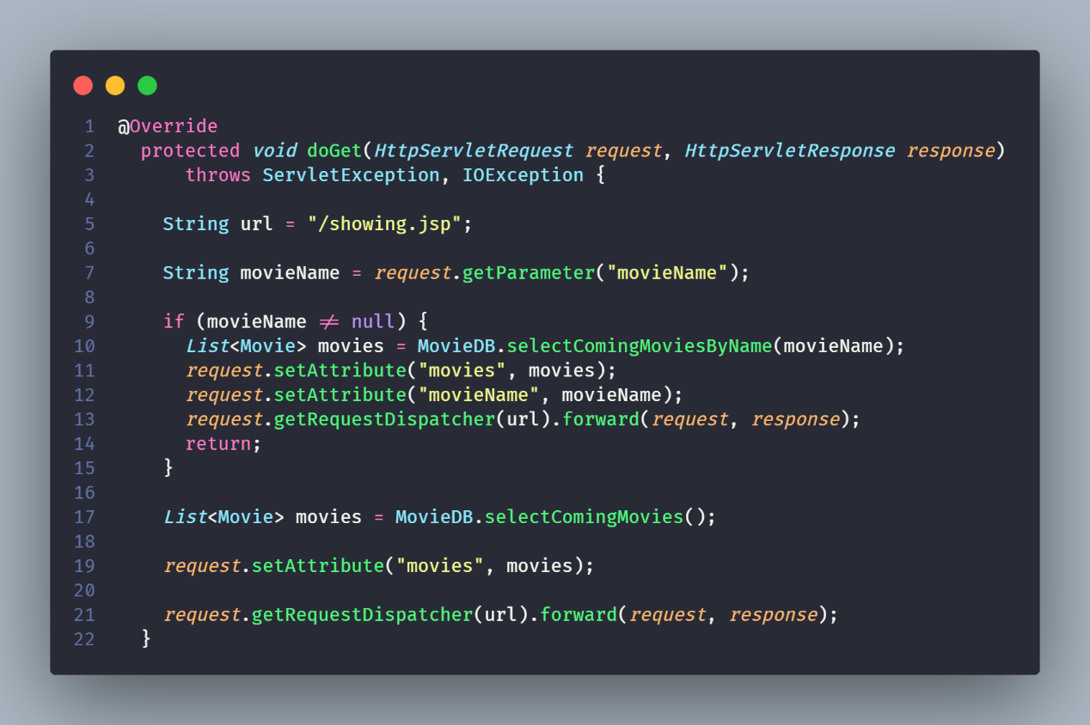

Figure 17 User showing servlet

This servlet handles the retrieval of movie showing information. It is mapped to the /showing URL pattern. The servlet's doGet method retrieves the movie name from the request, if provided, and retrieves the corresponding movies from the database. If no movie name is provided, it retrieves all upcoming movies. It then forwards the request to showing.jsp for rendering.

1. **User Ticket Servlet:**

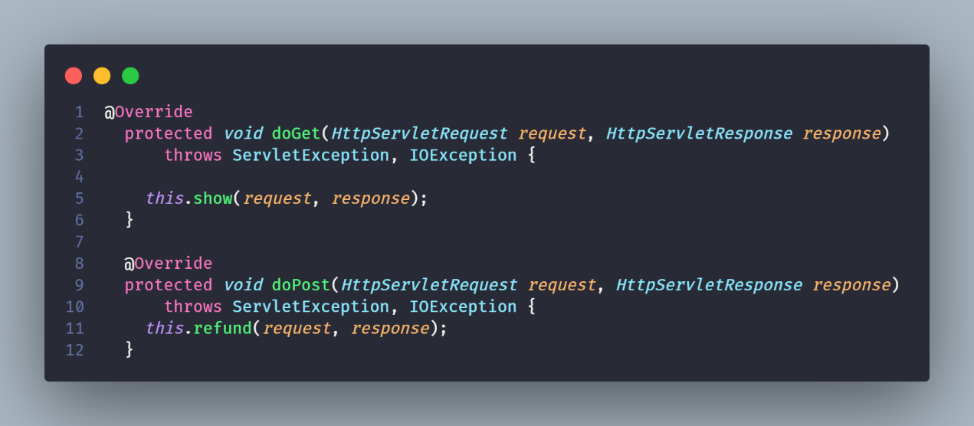

Figure 18 User ticket servlet

Table 7 User ticket servlet methods

|  |  |
| --- | --- |
| **Method name** | **Description** |
| show | This method is invoked when the servlet is accessed with a GET request. It retrieves the customer from the session or cookies, retrieves all invoices for the customer from the database, and forwards the request to ticket.jsp for rendering. |
| refund | This method is invoked when the servlet is accessed with a POST request. It retrieves the customer and invoice ID from the session and request, checks if the invoice exists and if the showtime is more than two days away, and if all checks pass, deletes the invoice, updates the customer's balance, and forwards the request to ticket.jsp for rendering. If any check fails, it forwards the request to ticket.jsp without making any changes. |

1. **User Seat Servlet:**

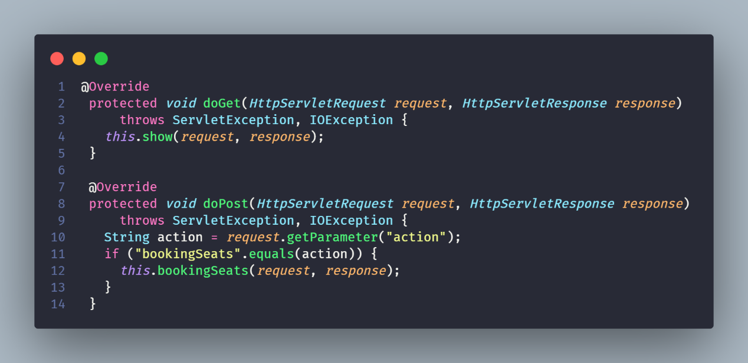

Figure 19 User seat servlet

Table 8 User seat servlet methods

|  |  |
| --- | --- |
| **Method name** | **Description** |
| show | This method is invoked when the servlet is accessed with a GET request. It retrieves the showtime ID from the request, retrieves the corresponding showtime from the database, and forwards the request to seat.jsp for rendering. |
| bookingSeats | This method is invoked when the servlet is accessed with a POST request and the action is "bookingSeats". It retrieves the customer from the session, the seat numbers and showtime ID from the request, checks if the customer exists and has enough balance, creates an invoice and tickets, updates the customer's balance, and inserts the invoice into the database. If any check fails or an exception occurs, it sets an error state in the session and redirects to the referer URL. If all checks pass and no exception occurs, it sets a success state in the session and redirects to the referer URL. |

1. **User Film Servlet:** His servlet handles the retrieval of movie information. It is mapped to the /showing/film URL pattern. The servlet's show method retrieves the movie ID from the request, retrieves the corresponding movie and its upcoming showtimes from the database, and forwards the request to film.jsp for rendering.

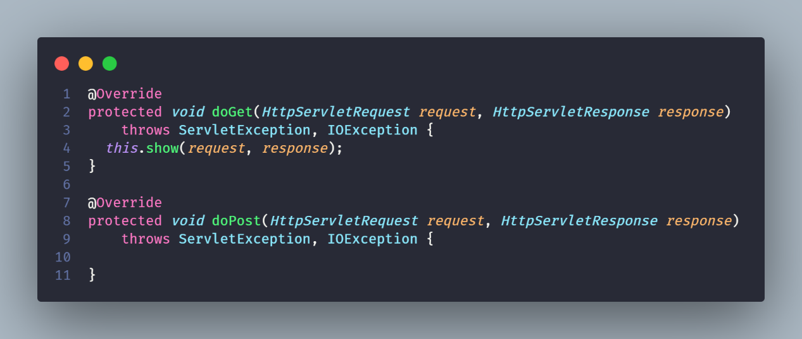

Table 9 User film servlet

Table 10 User film servlet methods

|  |  |
| --- | --- |
| **Method name** | **Description** |
| show | Responsible for fetching movie details and forwarding them to the film.jsp page for rendering. |

## **3.2. Frontend.**

### 3.2.1. Home page.

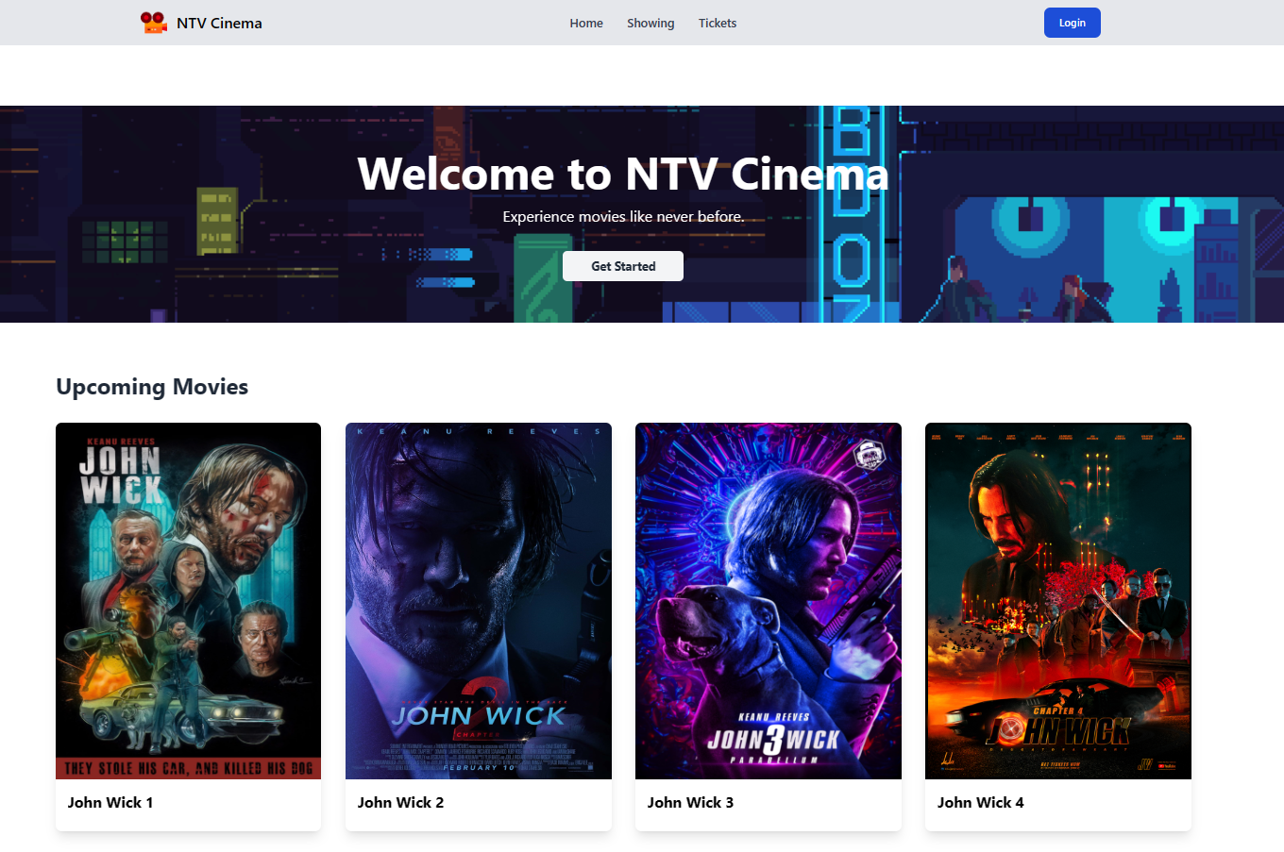

Figure 20 Homepage

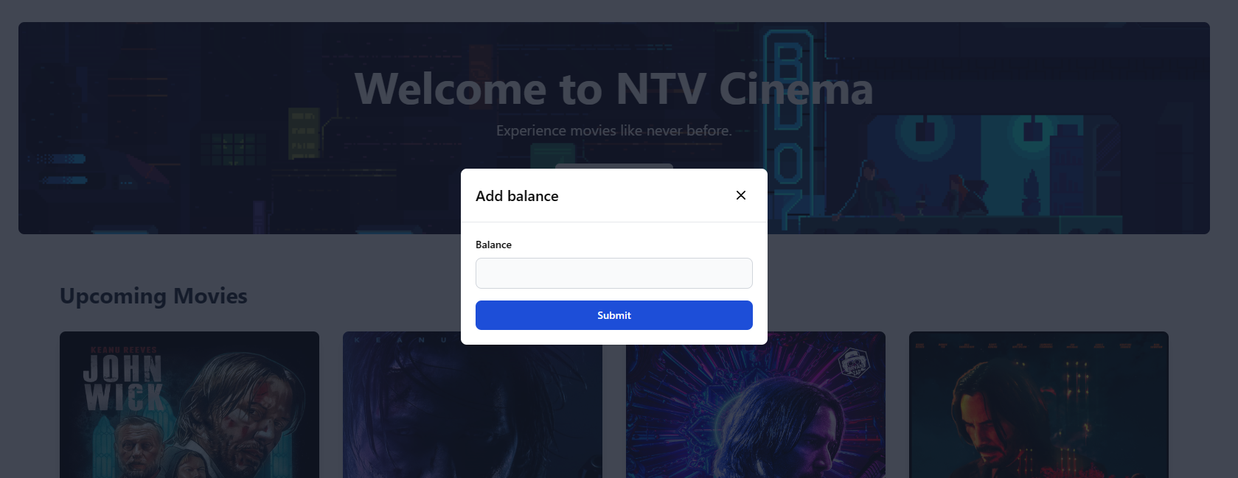

Figure 21 Add balance detail

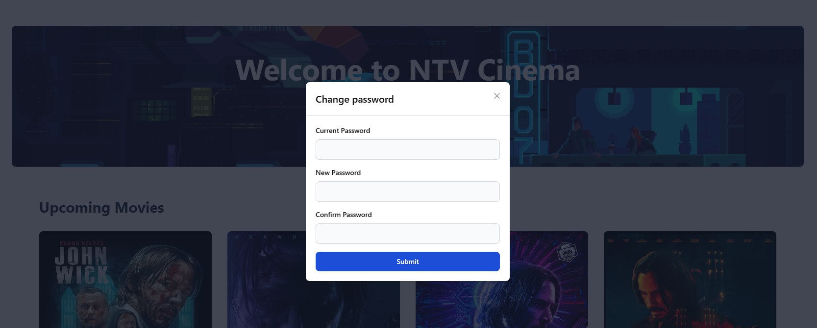

Figure Change password detail

### 3.2.2. Login page.

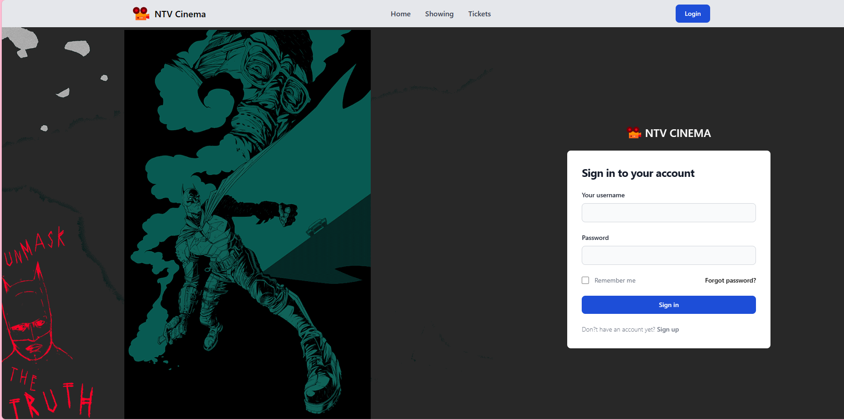

Figure 23 Login page

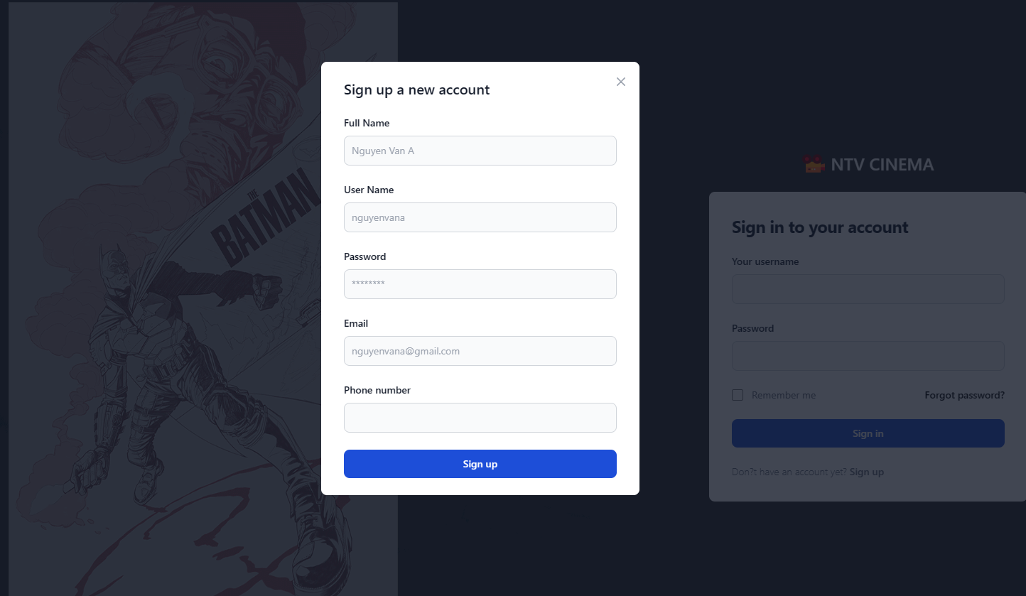

Figure 24 Sign up detail

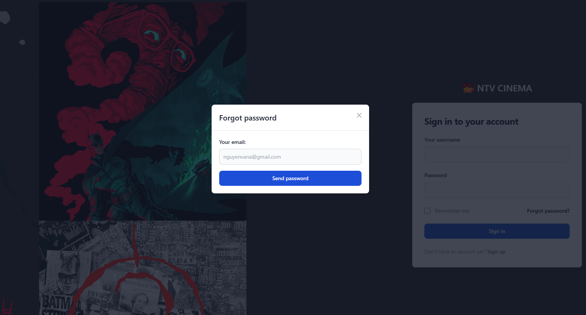

Figure 25 Forgot password detail

### 3.2.3. Showing movies page.

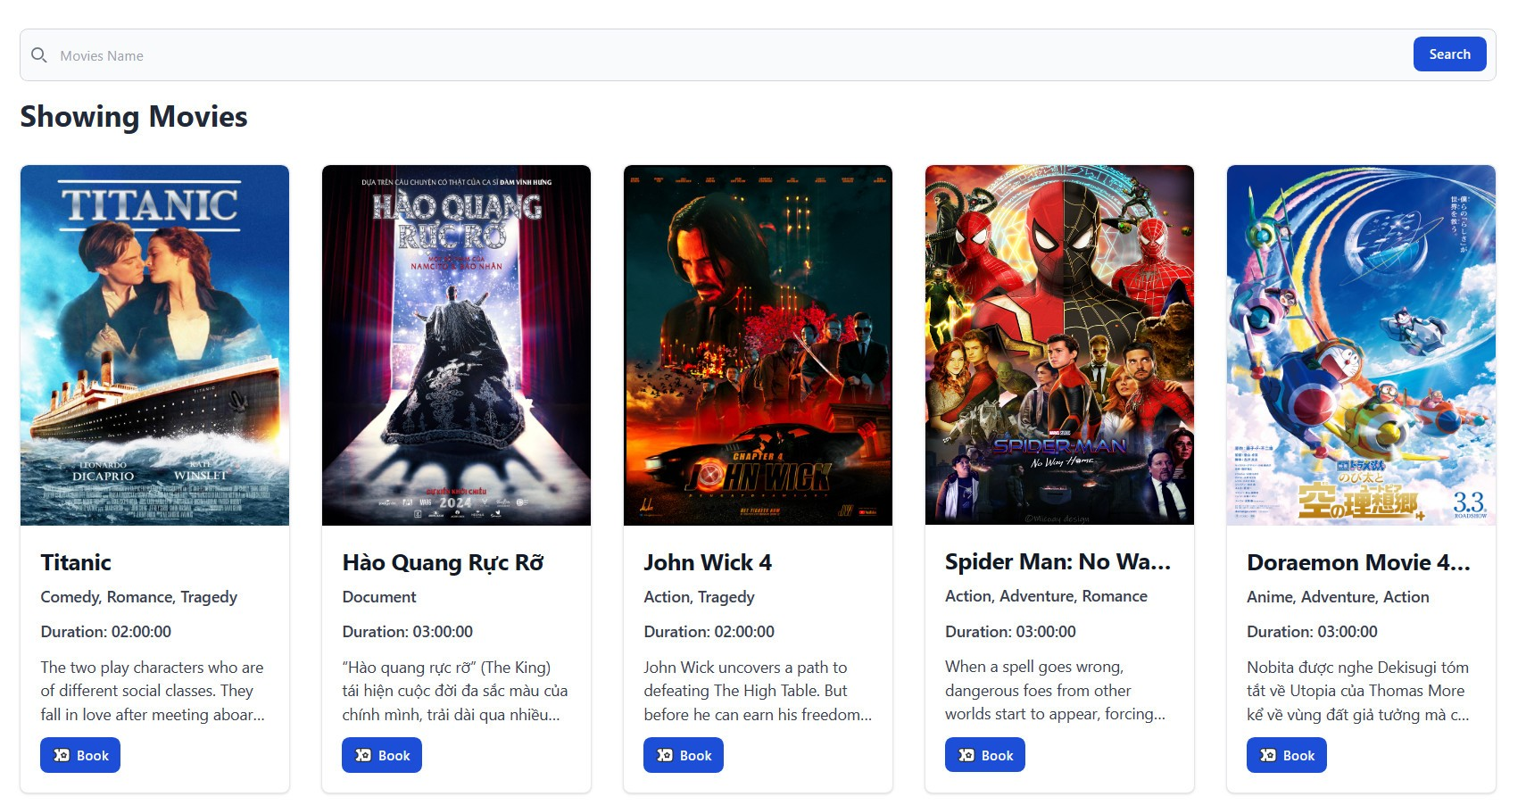

Figure 26 Showing movie page

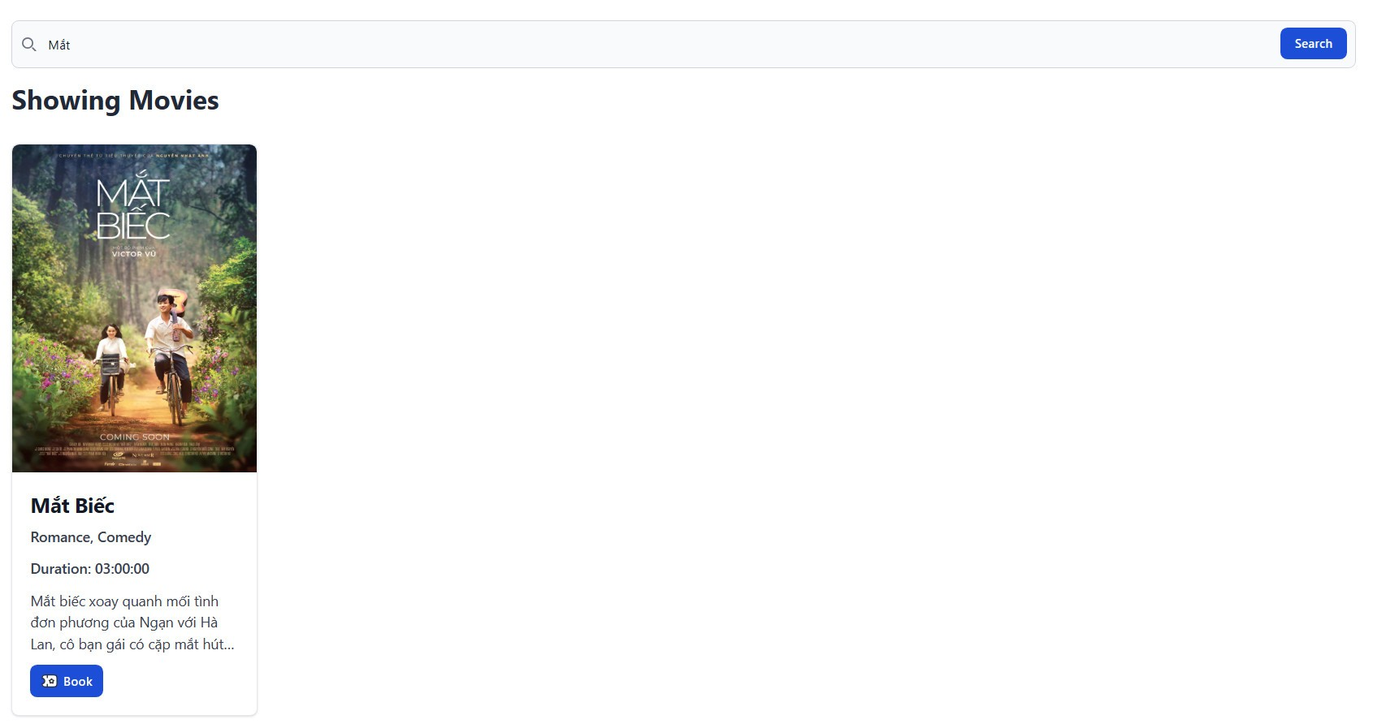

Figure 27 Browse showing movies

### 3.2.4. Tickets page.

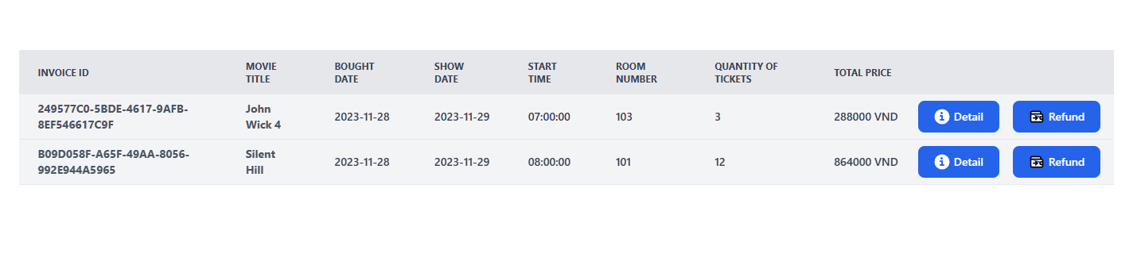

Figure 28 Tickets page

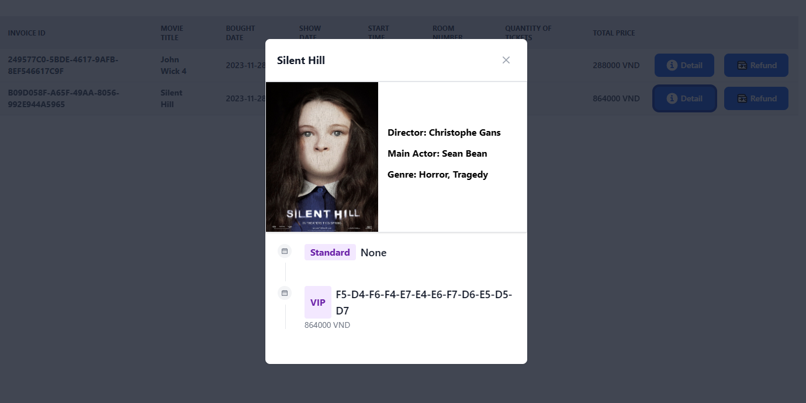

Figure 29 Ticket detail

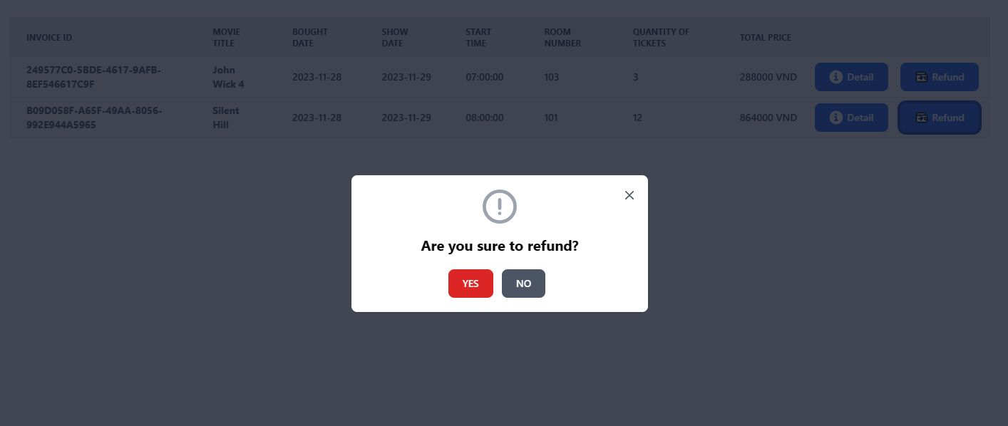

Figure 30 Refund detail

### 3.2.5. Film page.

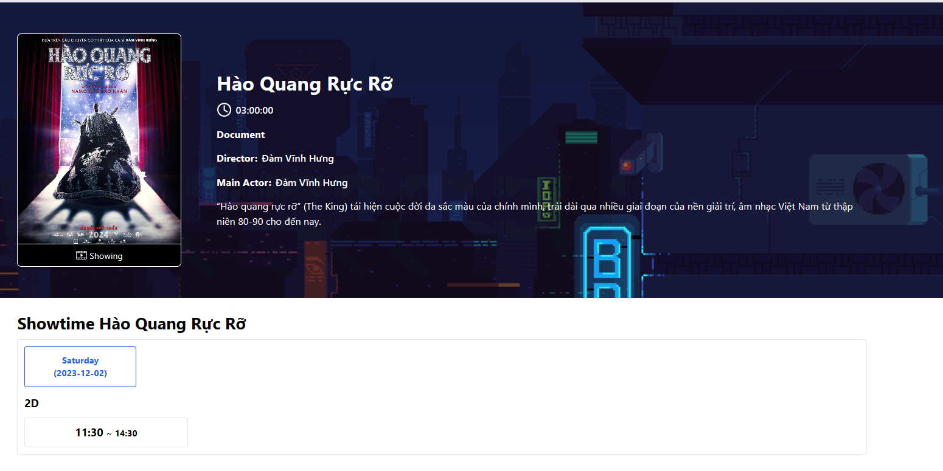

Figure 31 Film page

### 3.2.6. Booking page

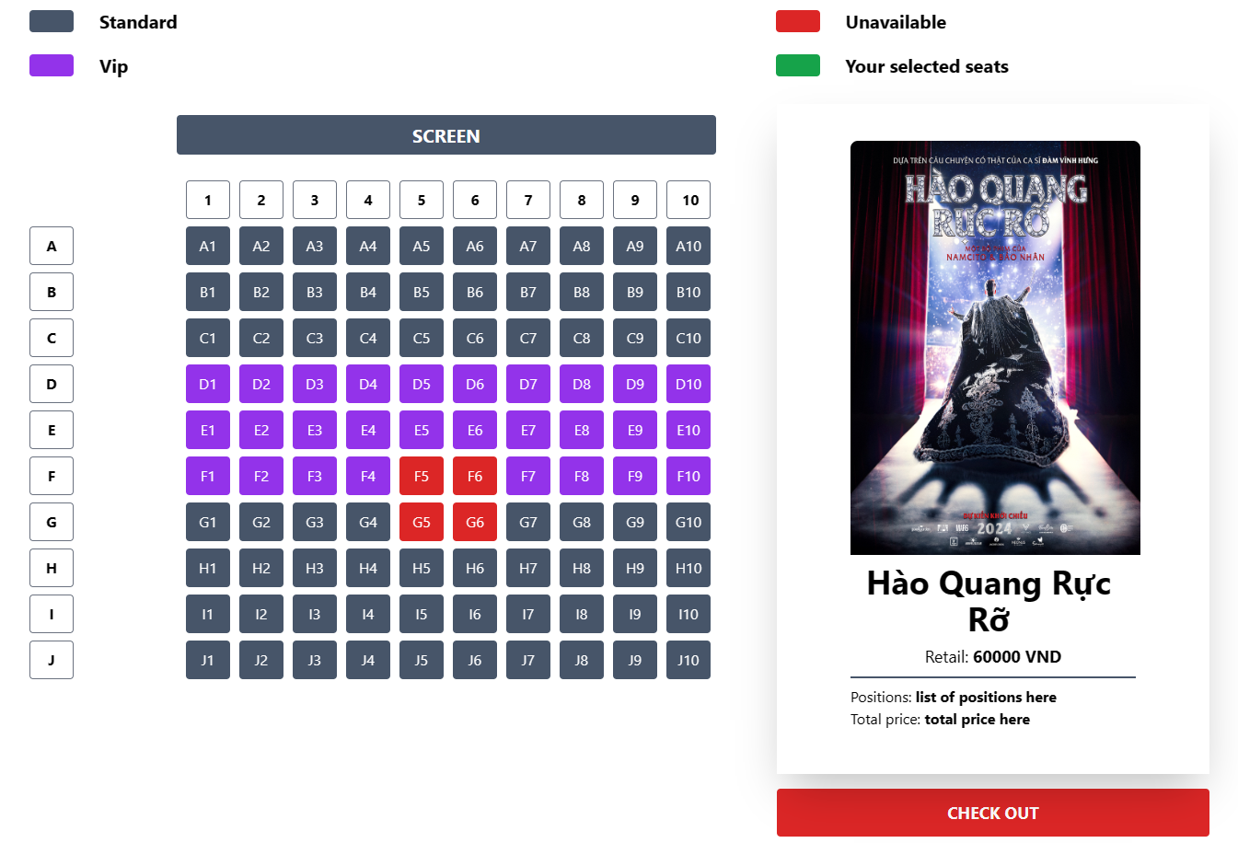

Figure 32 Booking page

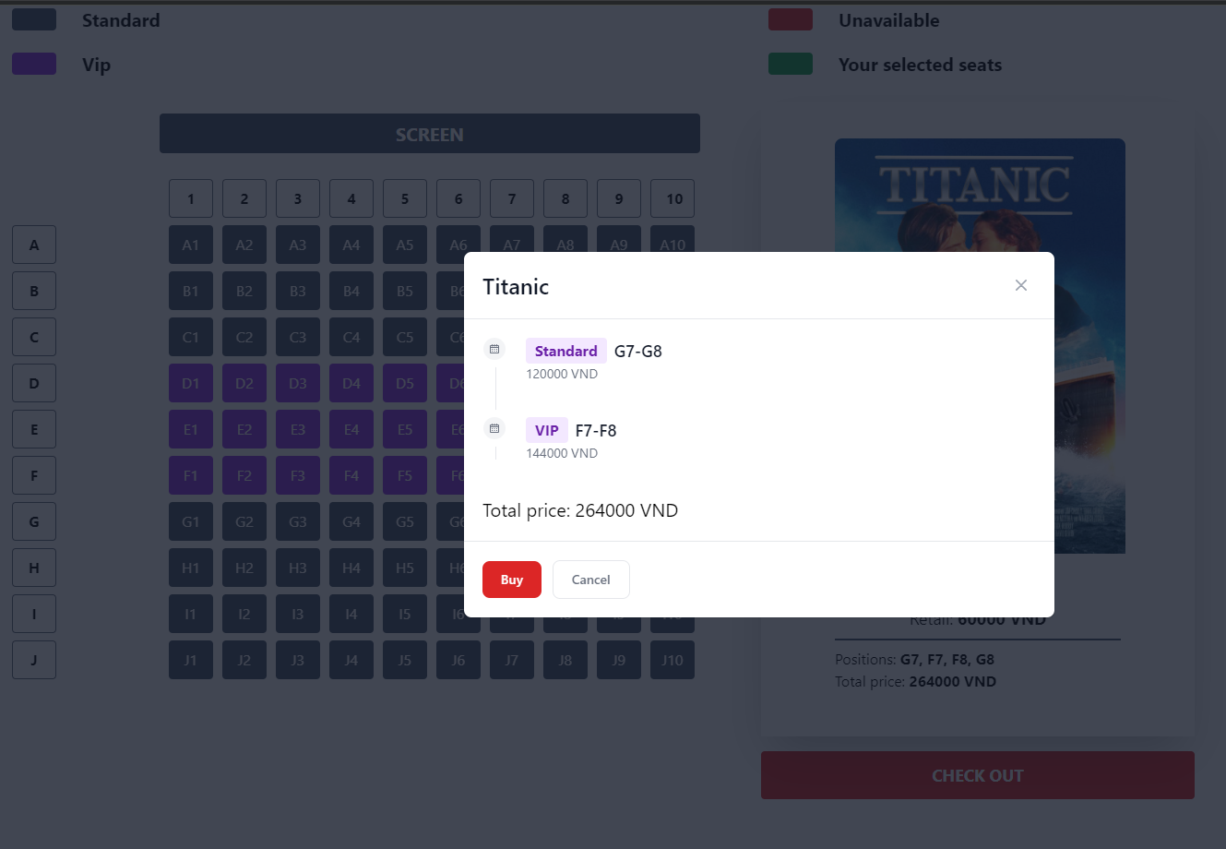

Figure 33 Check out detail

### 3.2.7. Admin page

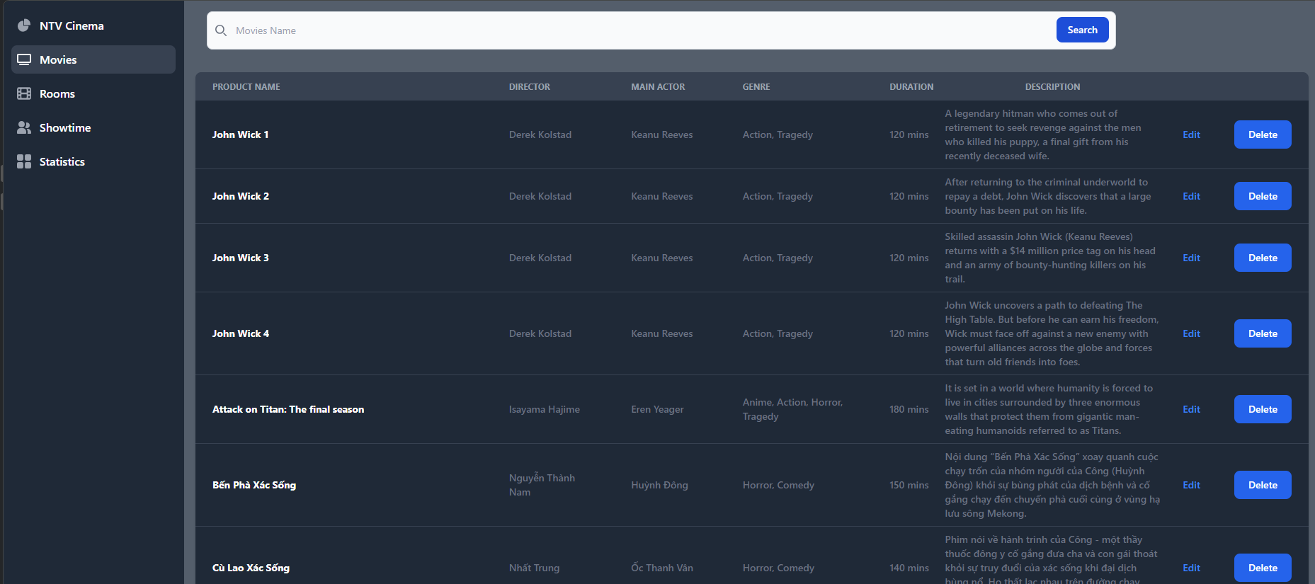

Figure 34 Admin page and movies detail

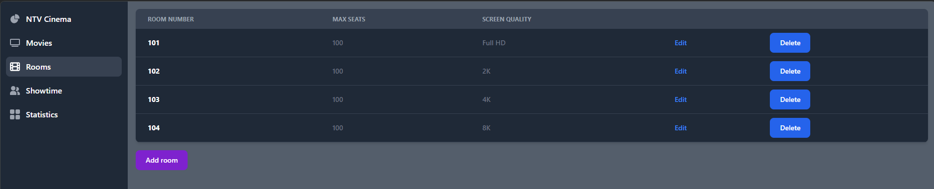

Figure 35 Room details

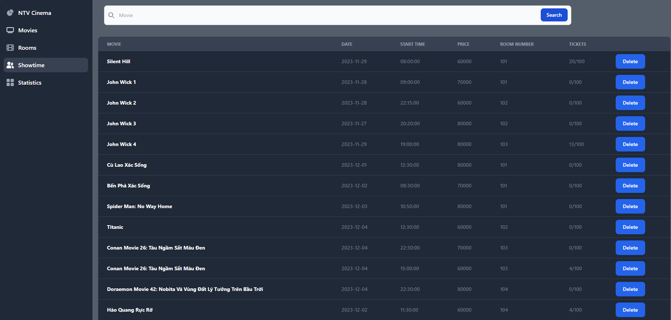

Figure 36 Showtime detail

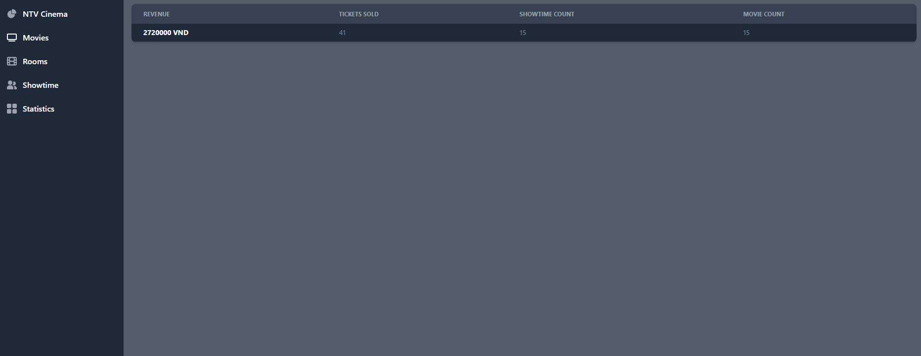

Figure 37 Statistics detail

# **CHAPTER 4: CONCLUSION**

## **4.1. Conclusion:**

**Advantage:**

* The implementation of the online ticket booking represents a significant leap forward in enhancing convenience, efficiency, and accessibility for users in the realm of ticket reservations. Real-time availability updates have not only simplified the booking process but have also contributed to an overall positive user experience.
* This web service eliminates the necessity for users to physically visit ticket counters; instead, they can effortlessly book tickets from the comfort of their homes and simply check in when attending the movies.

**Disadvantage:**

* Using online ticket booking services can be problematic due to technical issues or problems with internet connections.
* Users might face trouble getting onto the website, making payments, or getting confirmation, which could cause inconvenience and disrupt their plans. Moreover, relying on digital systems makes it possible for cyber threats, like unauthorized access to personal or payment information. This highlights the need for strong security measures to protect user privacy and financial details. Also, when features are not finished, it makes things difficult for both users and managers in using the system smoothly.

## **4.2. References:**

[1] Murach’s Java Programming (6th Edition). From: <https://www.murach.com/shop/murach-s-java-programming-6th-edition-detail>

[2] Connecting to The PostgreSQL Database. From: <https://www.postgresqltutorial.com/postgresql-jdbc/connecting-to-postgresql-database>

[3] Tailwindcss - Rapidly build modern websites without ever leaving your HTML. From: <https://tailwindcss.com>

[4] Flowbite - Build websites even faster with components on top of Tailwind CSS. From: <https://flowbite.com/>

[5] AOS - Animate On Scroll Library. From: <https://michalsnik.github.io/aos/>

**END**